Quick Evaluation Tool – Programming Team Connect

This evaluation should only take about 5 minutes to complete. It provides a quick opportunity to show that you are an expert at the basics for what this role will require. There are 3 sections: SQL understanding, C# understanding, data mapping exercise.

**SQL Understanding**

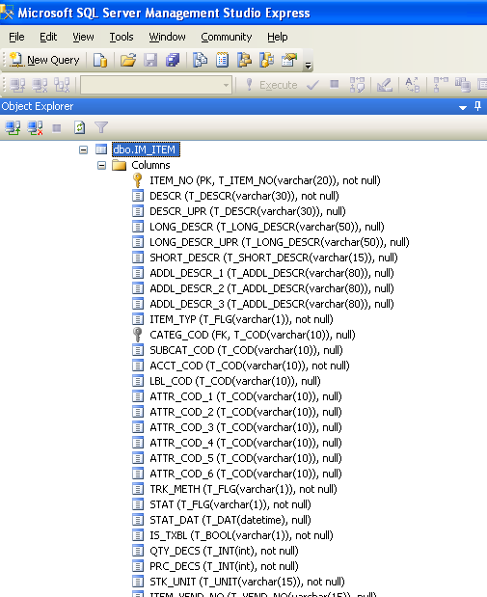

Using the screen shot above, please answer the following questions:

1. What is the column name of the primary key for the table?
2. The Primary Key is, of course, indexed. What other column(s) are indexed on this table?
3. Circle which of the following are valid values for PRC_DECS (expect to circle more than one):

128 3.28 -5 2 Y Green $&#*@( (5)

**C# Understanding:**

1. Given the table and its data below, what will the code produce when executed?

Table name: **AR_CUST**

|  |  |
| --- | --- |
| CUST_NO | EMAIL_ADRS_1 |
| 1001 | [abc@gmail.com](mailto:abc@gmail.com) |
| 1002 | [xyz@gmail.com](mailto:xyz@gmail.com) |
| 1003 | null |
| 1004 | [aaa@yahoo.com](mailto:aaa@yahoo.com) |
| 1105 | [wew@yahoo.com](mailto:wew@yahoo.com) |
| 1106 | null |
| 1107 | MISSING |
| 1108 | [wre@gmail.com](mailto:wre@gmail.com) |
| 1109 | MISSING |

var customerQuery = db.From<AR_CUST>().Where(c => c.EMAIL_ADRS_1 != null && c.EMAIL_ADRS_1 != "MISSING");

                List<AR_CUST> counterpointCustomers = db.Select(customerQuery);

                Console.WriteLine("Found " + counterpointCustomers.Count + " customers to add or update");

Output:

1. What will this code produce when executed?

using System;

  class Test {

    public static void Main()

    {

        int x = 10;

        while (x > 9 ) {

            Console.WriteLine("Value " + x);

            x++;

        }

    }

}

Output:

1. Given the table and its data below, what will the code produce when executed?

using System;

class Test {

    public static void Main()

    {

        string[] array1;

        array1= new string[3] {"California", "Washington", "Texas"};

        Console.WriteLine(array1 [0]);

        Console.WriteLine(array1 [1]);

        Console.WriteLine(array1 [3]);

    }

}

Output:

**Data Mapping Exercise:**

Using this dataset, fill in the mapping of the dataset into the appropriate columns in the table structure defined below.

|  |  |  |  |  |  |  |
| --- | --- | --- | --- | --- | --- | --- |
| Item # | Product Name | Last Sales Date | Unit Cost | Last Cost | Price | Category |
| 100 | Potting Soil 1 cu. ft. | 12/22/21 | $2.59 | $2.25 | $4.99 | Soil |
| 145 | 4” annual |  | $1.25 | $1.10 | $2.50 | Plants |
| 190 | Pottery | 11/15/21 | $4.15 | $4.10 | $8.25 | Pottery |
| A5463 | Apple tree 5g | 2/1/22 | $17.10 | $17.24 | $29.99 | Trees |
| B7132 | Fig tree 3g | 1/4/22 | $16.25 | $14.58 | $29.99 | Trees |
| R-100987 | Installation labor | 1/12/22 | $38.00 | $38.00 | $45.00 | Labor |

|  |  |  |
| --- | --- | --- |
| Column Name | Data Type | Column to map from dataset |
| ITEM_NO | VARCHAR(10) |  |
| DESCR | VARCHAR(25) |  |
| CATEG_COD | VARCHAR(10) |  |
| COST | DECIMAL(15,4) |  |
| PRC | DECIMAL(15,2) |  |
| ATTRIBUTE_1 | VARCHAR(50) |  |
| ATTRIBUTE_2 | VARCHAR(50) |  |
| LST_SOLD | DATETIME |  |
| LST_RECVD | DATETIME |  |
| QUANTITY | DECIMAL(15,2) |  |